CART - **ONLY FOR AUTH**-USERS + USERS CAN **SEE ONLY THEIR** CARTS

1.**front\layout.blade.php**

**@auth**

<li><a href="{{route('cart')}}">**Cart**</a></li>

**@endauth**

2.**routes\web.php**

/*

|--------------------------------------------------------------------------

| **Frontend**

|--------------------------------------------------------------------------|

*/

Route::prefix('')->namespace('Front')->group(function () {

*Route::name('home')->get('/', 'ShopController@index');*

*Route::name('product')->get('/product/{id}', 'ShopController@product');*

**Route::middleware('auth')->group(function () { //!!!ONLY AUTH-USERS**

Route::name('cart')->get('/cart', 'ShopController@cart');

Route::name('tocart')->post('/tocart', 'ShopController@tocart');

Route::name('clearall')->post('/clearall', 'ShopController@clearall');

Route::name('removeone')->post('/removeone', 'ShopController@removeone');

**});**

*Route::name('mailer')->post('/mailer', 'ShopController@mailer'); //mailer*

});

3.**ShopRepository.php**

/**

* Store to cart.

*

* @return \Illuminate\Contracts\Support\Renderable

*/

public function **tocart($request)**

{

//$this->model_cart->create($request->all());

//Cart::create($request->all());

//$this->model_cart->user_id = 1;

**$this->model_cart->user_id = auth()->user()->id; //!!!auth()->user()->id**

$this->model_cart->name = $request->name;

$this->model_cart->price = $request->price;

$this->model_cart->image = $request->image;

$this->model_cart->save();

}

/**

* Create a query for Cart.

*

* @return \Illuminate\Database\Eloquent\Builder

*/

public function **fromcart()**

{

$query = $this->model_cart

->select('id', 'user_id', 'name', 'price', 'image')

**->where('user_id', auth()->user()->id); //!!!auth()->user()->id**

return $query->get();

}

4.**views\front\cart.blade.php**

**УБРАТЬ**

**<th>User</th>**

**views\front\brick-standard-cart.blade.php**

**УБРАТЬ**

**<td>**

**<span>{{$cart->user->name}}</span>**

**</td>**

**cart for ALEX**

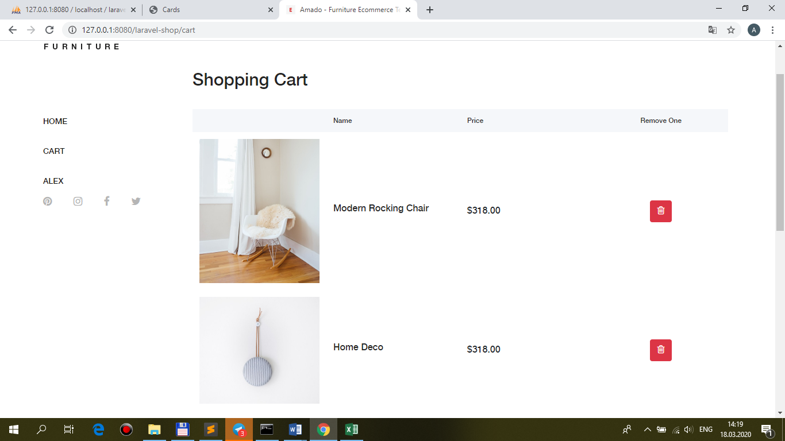

**cart for SERG**

